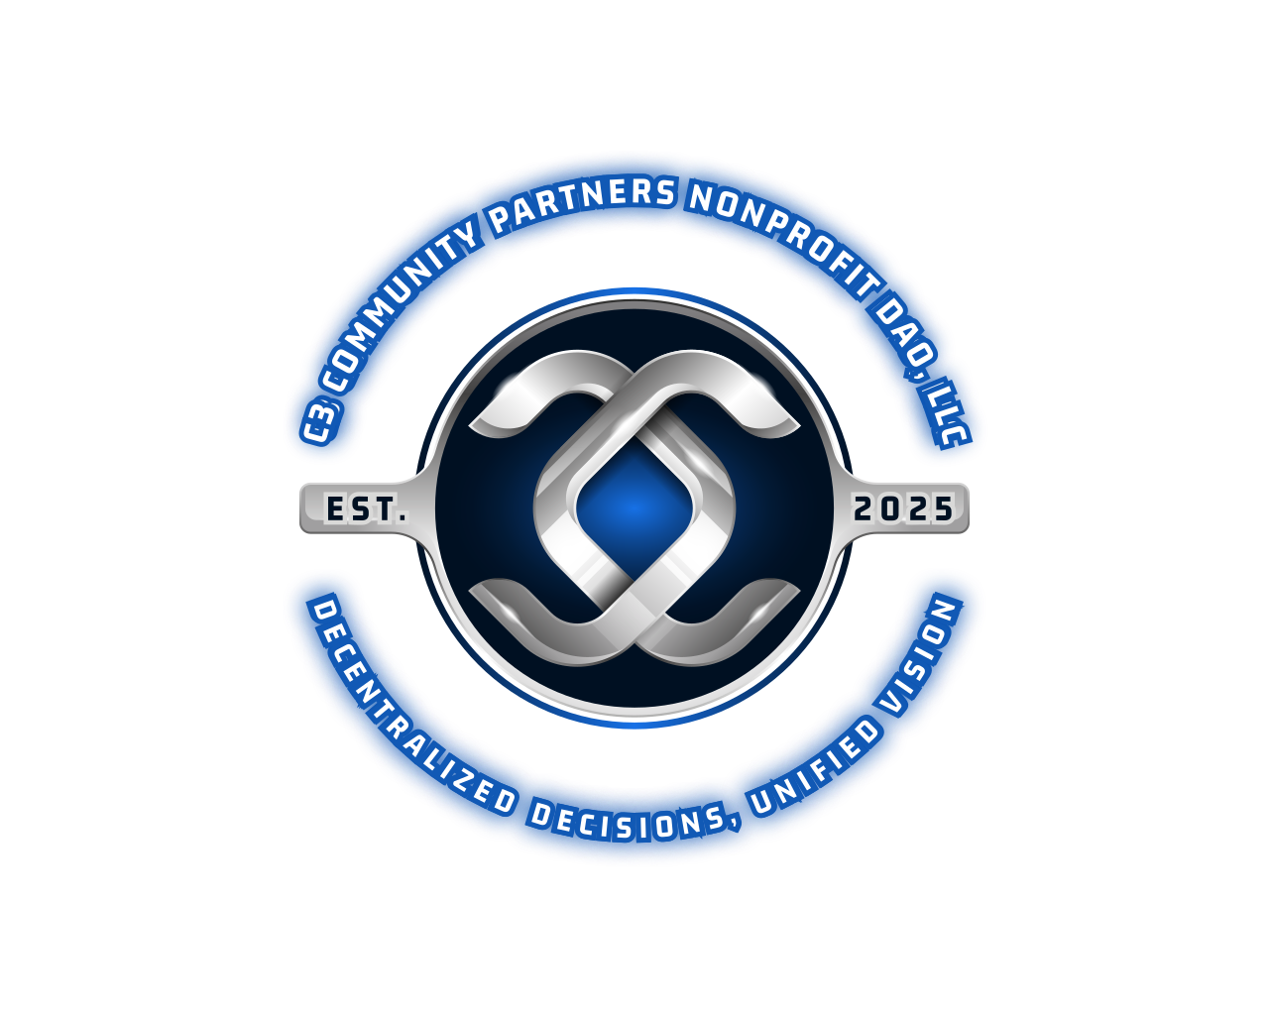

**Articles of Organization for c3 Community Partners DAO, LLC**

**Article I: Name**

The name of the limited liability company is **c3 Community Partners DAO, LLC**.

**Article II: Duration**

The duration of the LLC shall be perpetual unless dissolved in accordance with the provisions of these Articles or applicable law.

**Article III: Principal Office**

The principal office of the LLC is located at **805 Oak Leaf Dr, Old Hickory, TN, Wilson County**.

**Article IV: Purpose**

The purpose of the LLC is to operate as a nonprofit decentralized autonomous organization dedicated to fostering local business partnerships that enhance community development in underserved communities in Tennessee. The organization aims to drive sustainable initiatives that improve living standards and promote civic engagement among residents. The LLC may engage in any lawful activity permitted under the laws of the State of Tennessee.

**Article V: DAO Governance**

This LLC shall be governed as a decentralized autonomous organization (DAO) utilizing blockchain technology and Web 3.0 principles. A robust decentralized application (dApp) will be developed to support partner accountability and ownership through contributions and voting. Additionally, smart contracts will be implemented to ensure transparency and accountability in all transactions and governance processes. This dApp and the associated smart contracts will facilitate transparent decision-making, allowing members to actively participate in governance and ensuring that their contributions are recognized and valued. The specific governance procedures, including voting mechanisms and member participation, shall be detailed in the operating agreement.

**Article VI: Partners**

Each and every c3 Community Partner, whether a founding partner, community member, business organization, or investor, enters into an agreement with every current standing partner as well as subsequent partners without prejudice. This agreement emphasizes mutual respect, shared responsibilities, and a dedication to the collective mission. The names and addresses of the founding partners are as follows:

1. **Stephanie Joanne Gaffney, 805 Oak Leaf Dr, Old Hickory, TN 37138**

2. **David Michael Perry, 805 Oak Leaf Dr, Old Hickory, TN 37138**

3. ** Katherine Danielle Gaffney 5636 Old Hickory Blvd, Hermitage, TN 37076

**Article VII: Partner Contributions and Tokenized Economy**

The operating agreement will outline contribution requirements for all partners, including financial, in-kind, and other forms of support. Additionally, the use of a tokenized economy will be established, detailing the issuance, use, and distribution of tokens within the organization. These tokens will serve as a means of facilitating transactions, rewarding contributions, and enabling participation in governance processes. The specific mechanisms for token distribution and utilization will be defined in the operating agreement.

**Article VIII: Profits and Losses**

As a nonprofit organization, any profits generated shall be reinvested into the organization’s mission and activities, and losses shall be managed in accordance with the operating agreement.

**Article IX: Indemnification**

The LLC shall indemnify its members to the fullest extent permitted by law against any and all expenses and liabilities incurred in connection with the LLC.

**Article X: Amendments**

These Articles of Organization may be amended by a majority vote of the members, as outlined in the operating agreement.

**IN WITNESS WHEREOF**, the undersigned have executed these Articles of Organization on this 25th Day of March in the year of 2025].

STEPHANIE JOANNE GAFFNEY

DAVID MICHAEL PERRY

KATHERINE DANIELLE GAFFNEY

---

### Additional Considerations:

1. **Operating Agreement**: It’s essential to draft a detailed operating agreement that outlines governance, decision-making processes, member rights, responsibilities, and specifics regarding the tokenized economy.

2. **Nonprofit Compliance**: Ensure compliance with state and federal regulations regarding nonprofit organizations, including tax-exempt status if applicable.

3. **Legal Consultation**: Consulting with a legal expert familiar with nonprofit and DAO regulations is highly recommended to ensure all aspects are covered.

By establishing a clear framework for **c3 Community Partners DAO, LLC**, you can empower your members to collaborate effectively and drive meaningful change in underserved communities in Tennessee. If you have any further questions or need assistance, feel free to ask!